Running Programs On HPC

- Set up a tunnel to hpc.csse.uwa.edu.au:8080 from your local machine. If you need help wth this, there arre plenty of tutorials on Google.

- Visit the local address in your web browser (i.e. http://localhost:8080/). You should get the following website.
- Click on Log In in the top right. Then click on “create an account”.
- Enter your student number as the username, then fill out the other parts of the form.
- Go back to the main page, then click “create new jobs”.
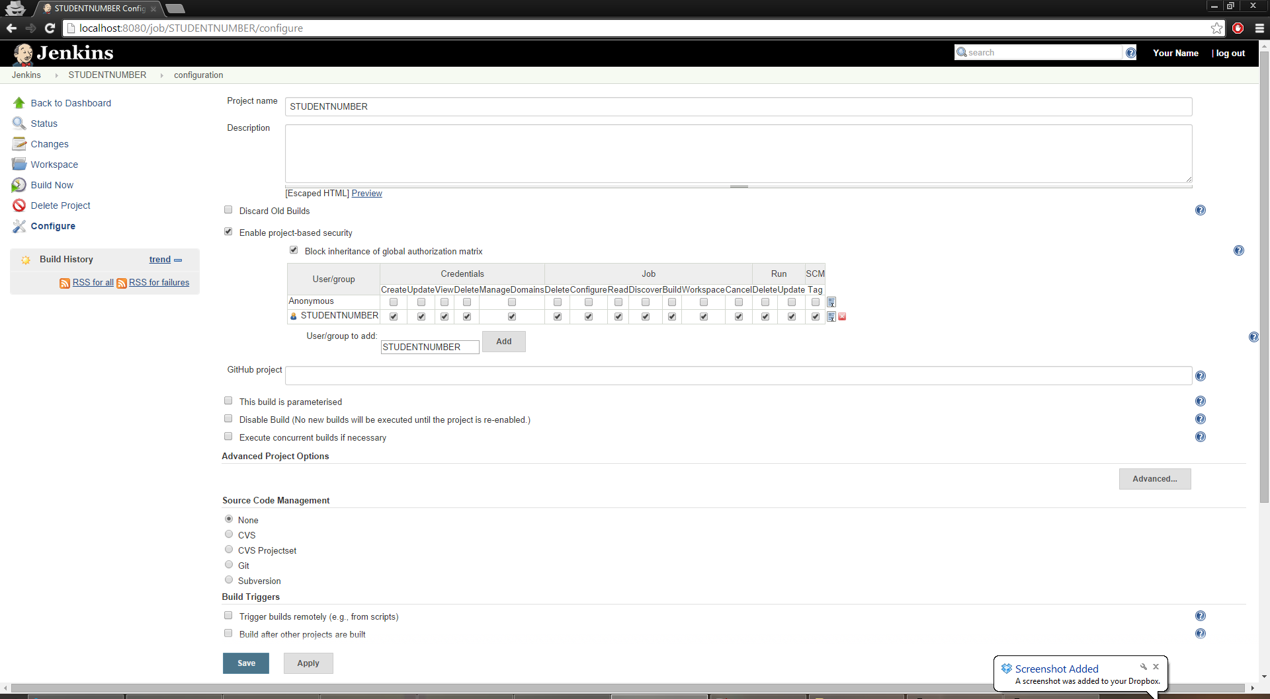
- Enter your student number under “Item name” and select “Freestyle project”, then click Okay.
- Tick “Enable project-based security”, and then click “Block Inheritance of global authorization matrix”.
- Add your user name and tick all of the boxes.
It should end up looking like the following.
NOTE: You can add other people here so they can use the same job. This is useful if you are working in a pair.
- Scroll down to build environment and tick “Abort the build if it's stuck”.
Set time-out strategy to “Absolute” and minutes to 10.
- Click add action then select “Abort The Build”.
- Scroll down to build and click “Add a Build Step”. Select “Execute Shell”.
- Enter the commands you want to run.
For example:
wget http://undergraduate.csse.uwa.edu.au/units/CITS3402/labs/breather.c
gcc breather.c
./a.out
- Click Save.
- Click on “Build Now” to execute run your job and execute your code.

